How to Change Labels

1. Click on Issues.

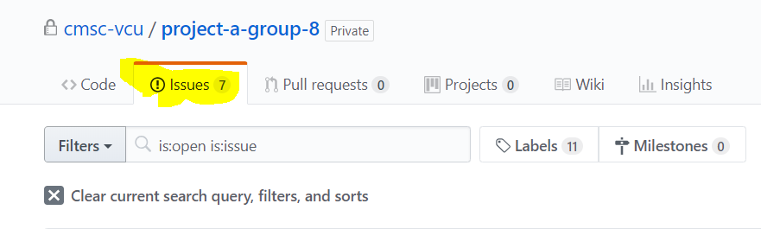

1. Click on the Issue

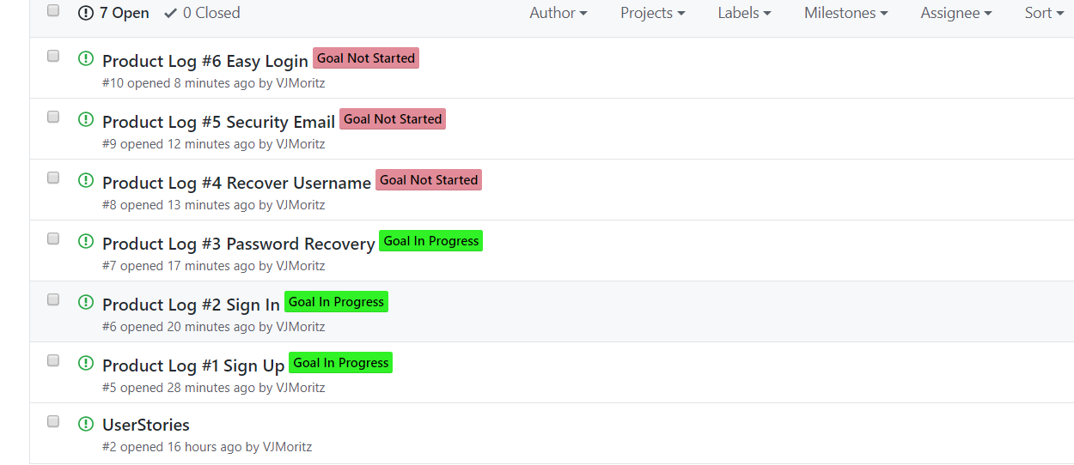

1. Click on Labels

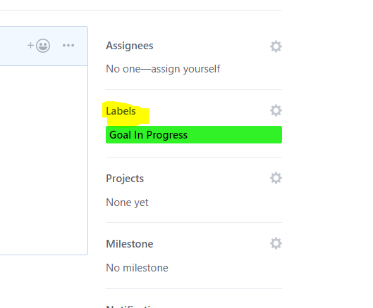

A List should appear that list all of the labels. A check mark shows that that label has been applied to the Issue. Pick the label you want.

